NEMCO DICED BEETS IN BRINE in 6/10 CAN
NEMCO UPC Barcode: 767301402680

Product Description:
They are preserves obtained from fresh roots of Daucus carota L. devoid of skin, roots and leaves, packed in tin containers with liquid of government and treated conveniently by pasteurization, resulting in a commercially sterile end product. Product of Spain.

NEMCO products are certified as Kosher when bearing the symbol on the label.

Nutrition Information:

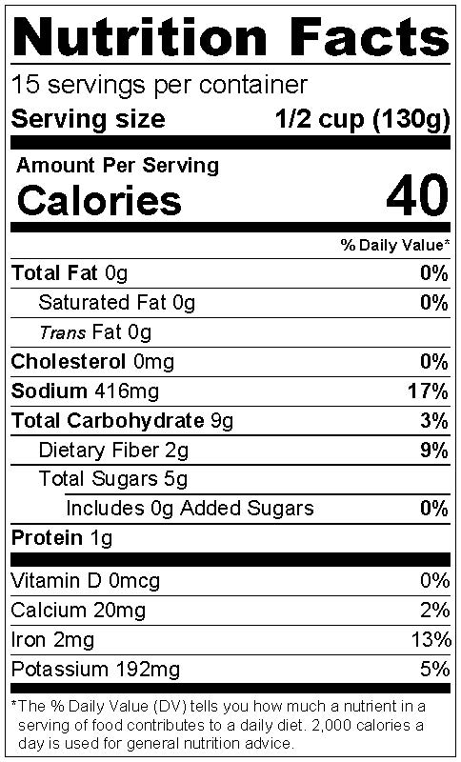
Ingredients:
Beetroot, Water, Salt, Citric Acid and Ascorbic Acid

Physical Analysis:
Color: Typical
Taste/Odor: Typical
Texture: Typical
Consistence: Firm
pH: ≦4.0
Microbiological Standards: Commercially sterile

Storage:
Keep in a dry and cool place. Ambient, suggested temperature between 40 °F - 80 °F. Protect from direct sun light.
Shelf Life 4 years.

Product Handling:
After opening, transfer the content and brine to a non-metallic container with the maximum of liquid as possible, keep refrigerated and finish before 5 days.

Packaging:
Case Size: 6/10
Net Weight: 2,900g (102 oz)
Drained Weight: 1,980g (70 oz)
Case Dimensions: 18.5” x 12.25” x 7.0”
Case Cube: 0.92 CFT
Cases/Pallet: 56 CS/P

