LOLITA MIXED WHOLE CHERRY PEPPERS IN A 1 GALLON CONTAINER, PRODUCT OF EGYPT

NEMCO UPC Barcode: 767301402735

**Product Description:**

Whole mixed cherry peppers, uniform in size and color, in brine, packed in PET plastic gallon with induction seal. Allergen free, no GMO’s

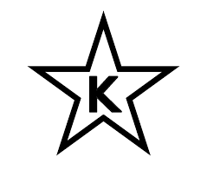

NEMCO products are certified as Kosher when bearing the symbol on the label.

**Nutrition Information:**

**Ingredients:**

Mixed cherry peppers, water, salt, acetic acid, citric acid, sodium benzoate and sodium metabisulfite (preservative), FD & C yellow #5

**Physical Analysis:**

Color: Characteristic (greenish/reddish)

Taste/Odor: Fresh with no aftertaste and free from any foreign smell

Texture: Firm and fully cured

Consistence: Tender

pH: 2.7 – 3.0

Microbiological Standards: Commercially sterile

**Storage:**

Keep in a dry and cool place. Ambient, suggested temperature between 40 °F - 80 °F. Protect from direct sun light.

Shelf Life 2 years.

**Product Handling**

After opening, keep refrigerated and finish before 30 days.

**Packaging:**

Case Size: 4/1 gallon

Net Weight: 3750 gm (132.28 oz)

Drained Weight: 1600 gm (56.44 oz)

Case Gross Weight: 34.613 lbs

Case Dimensions: 30” x 30” x 27”

Cases/Pallet: 60 CS/P