LOLITA DICED GREEN PEPPERS in 6/10 can

NEMCO UPC Barcode: 767301402703

**Product Description:**

Diced green peppers, product of Turkey.

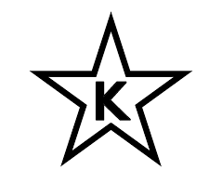

NEMCO products are certified as Kosher when bearing the symbol on the label.

**Nutrition Information:**

**Ingredients:**

Green peppers, water, salt, sugar, citric acid, calcium chloride

**Physical Analysis:**

Color: Typical green color, no rotten, clear brine

Taste/Odor: Typical of bell pepper, no off taste or odor

Texture: Typical texture, not mucous

pH: 3.5 – 4.0

Microbiological Standards: Commercially sterile

**Storage:**

Keep in a dry and cool place. Ambient, suggested temperature between 40 °F - 80 °F. Protect from direct sun light.

Shelf Life 3 years.

**Product Handling:**

After opening, transfer the content and juice to a non-metallic container with the maximum of liquid as possible, keep refrigerated and finish before 5 days.

**Packaging:**

Case Size: 6/10

Net Weight: 3,050 g (107.58 oz)

Drained Weight: 1,800 g (63.49 oz)

Case Dimensions: 18.7” x 12.4” x 7.0”

Case Cube: 0.94 CFT

Cases/Pallet: 56 CS/P