LOLITA SLICED BANANA PEPPERS in 4/1 GAL PET
NEMCO UPC Barcode: 767301140452

Product Description:

Sliced Banana Peppers. Product of Egypt.
LOLITA products are certified as Kosher when bearing the symbol on the label.

Nutrition Information:

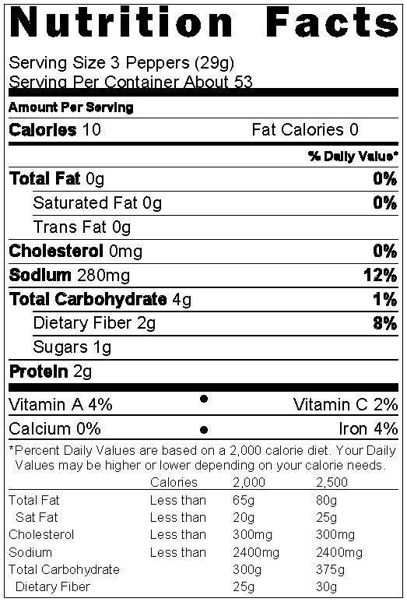
Ingredients:
Banana Pepper, Water, Salt, Acetic Acid, Citric Acid, Sodium Benzoate, Sodium Meta Bisulfite, Capsaicin, Turmeric

Physical Analysis:
Appearance/Color: Yellow color, slices with thickness
5-8 mm
Taste/Odor: Sweet as flavor
Texture: Firm and fully cured texture
pH: About 3.2
Acidity: 1.5 – 2%

Storage:
Keep in dry, ambient, temperature between 40 °F - 80 °F.
Protect from direct sun light.
Shelf Life 2 years.

Product Handling:
After opening, transfer to a covered air-tight storage container, refrigerate and use within 30 days.

Packaging:
PET Size: 4/1
Net Weight: 3,800g (134 oz)
Drained Weight: 1,700g (70 oz)
Case Dimensions: 12x10x11
Case Cube: 0.76 CFT
Cases/Pallet: 60 CS/P (Ti x Hi = 12 x 5)

