LOLITA ROASTED RED CAPIA PEPPERS in 6/10 can

NEMCO UPC Barcode: 767301131672

**Product Description:**

Canned ROASTED RED PEPPERS. Product of Peru.

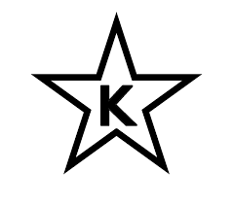NORTHEAST products are certified as Kosher when bearing the symbol on the label.

**Nutrition Information:**

**Ingredients:**

Red Peppers, Water, Salt, Citric Acid

**Physical Analysis:**

Appearance/Color: Typical Red Color, No Rotten, Clear

Brine

Taste/Odor: Typical Taste and Odor

Texture: Firm

pH: Less than 4.0

GMO: GMO-Free

**Storage:**

Keep in dry, ambient, temperature between 35.6 °F - 77 °F.

Protect from direct sun light.

Shelf Life 3 years.

**Product Handling:**

After opening, transfer to a covered storage container, refrigerate and use within 4 days.

**Packaging:**

Case Size: 6/10

Net Weight: 2,900g (102 1/4 oz)

Drained Weight: 1,800g (63.5 oz)

Case Dimensions: 18.5x12x7

Case Cube: 0.90 CFT

Cases/Pallet: 56 CS/P