NEMCO CHUNK LIGHT TONGOL TUNA IN 66.5 OZ CAN, HORIZONTAL PACK NO ADDS

NEMCO UPC Barcode: 767301140377, Product of Vietnam

**Product Description:**

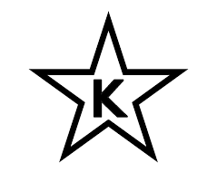Tongol tuna chunks in brine, no additives.

NEMCO products are certified as Kosher when bearing the symbol on the label.

**Nutrition Information:**

**Ingredients:**

Tongol tuna, water, salt

**Physical Analysis:**

Color: Light beige

Taste/Odor: Typical, fishy with no off taste or odor

Texture: Fairly firm, uniform, not soft or pasty

Consistence: Firm

pH: 5.5 – 6.5

Microbiological Standards: Commercially sterile

**Storage:**

Keep in a dry and cool place. Ambient, suggested temperature between 40 °F - 80 °F. Protect from direct sun light.

Shelf Life 3 years.

**Product Handling:**

After opening, transfer the content and brine to a non-metallic container with the maximum of liquid as possible, keep refrigerated and finish before 5 days.

**Packaging:**

Case Size: 6/66.5

Net Weight: 1880 g (66.315 oz)

Drained Weight: 1360g (47.97 oz)